**DAT536: Database Development and Design**

**Assignment 2**

**Student name: Ziyang Liao (George)**

**Student ID: S00019838**

**Part A – Project Planning and Analysis**

1. **Business overview**.
2. The Mt Albert Football Club offers club services to its members. Services include supporting and training football players, appointment management for physiotherapists, players and employees. The club has two types of memberships: one is for the football players, and another is for the employees. As the number of players is growing, the club needs a database management system (DBMS) to support its operation.
3. The DBMS is designed to support the club’s operation with recording data, managing memberships and appointments, automating database processes and procedures. It enhances the club’s process and systems in multiple ways as below:

1). Data consistency and accuracy.

The club’s database contains a large amount of data It is important to keep data consistent and accurate. The DBMS helps the management team to make sure all data is correctly recorded and stored in the database.

2). Data privacy.

The club’s database contains sensitive data on the personal information of players and employees. It’s important to protect data privacy. The DBMS secures data security by giving users access with privileges accordingly: only authorized users have access to the database; each user will be given a unique user ID and a password; each user will be given their database privileges based on their membership type and their role in the club.

3). Quick data access and user productivity.

The DBMS produces answers to queries promptly, provides users with required data fast and efficient when needed. The available data will be transformed into helpful information for the users. This will help the club’s management team manage the members and appointments efficiently.

4). Safe data backup and recovery.

The DBMS has a function that allows the data to be backup automatically, which means data will be backup regularly. The backup data can be used for recovery if there is data lost after a system failure or crash. These will help the club to backup data and recover data when needed. This will help the club to gain the data safety and trust of club members.

*(What Are the Advantages of Database Management System?- Talent Economy, 2021)*

1. **Business requirements:**

It’s important to understand the club’s business requirements for exact features and functionalities before designing the DBMS. To define the business requirements, both functional and non-functional requirements are listed are below.

1. **Functional requirements.**

Functional requirements descript the whole DBMS or its specific function that should perform when certain conditions are met. These requirements include technical details, calculations, data manipulation and processing.

The functional requirements are:

1). Authentication of users. The DBMS must verify the identity when a user enters the system with their username and password.

2). Sending verification emails. The DBMS must send a verification email straight away after a new club member is registered in the system.

3). The DBMS server must back up data automatically as scheduled. As the DBMS manages a large number of users, there will be new data being entered or existing data being modified frequently. It’s important that the DBMS updates the data regularly.

1. **Non-functional requirements.**

Non-functional requirements describe the quality attribute of a software system. They don’t include the basic functionality of the DBMS. They are used to make sure the DBMS meets user expectations. *(Andrieiev, 2020).*

Non-functional requirements as below:

1). Usability. The DBMS is very user friendly. A new user will be confidently able to use the application after a brief training. And because of its supporting multiple platforms including Microsoft Windows, Linux and Mac OS, a user can login to the application from most of devices as they wish.

2). Security. The DBMS manages sensitive information of its members and the data is not to be compromised at any time. The DBMS provide security to protect its data from unauthorized access. A user must provide a verified username and password to access the application. Also each user can only access to or view the data that is given privileged by the administrator.

1. **Technical and administrative details.**
2. **The suitable DBMS for the club is MySQL.**

The benefits of using MySQL:

* Open source and user-friendly.
* Fast speed.
* Multi-user function. This suits the club’s big membership base.
* Robust SQL database server will help the club management team to provide efficient and productive services.
* Supporting multiple platforms including Microsoft Windows, Linux and Mac OS.
* Different versions for choices including free and paid versions. This allows the club to choose the right package to suit their need.

(Page 58, *DAT536 Course Book.pdf: Database Development and Design*, 2021)

1. **Storage for Data backup:**

There are three ways to store the club’s data backup: the computer hard drive, external hard disk, and cloud storage. These three backup methods should all be used at the same time to have an extra backup in place for safety measures.

Cloud storage is the best option as compared to the other two methods. Cloud storage is a ‘hard drive’ that works through the internet which stores user files onto an external remote server such as Good Docs. Here are the reasons for choosing cloud storage:

1). Remote access. With cloud storage, the DBMS backup files can be accessed from anywhere via the internet.

2). Multi platforms. As the system supports multiple platforms, users can access files from their devices such as a smartphone, laptop, or desktop computer.

3). Extra safety. With cloud storage, the backup files are stored externally on the cloud server. This provides extra safety from the circumstances that in other instances such as the hard drives or the computers got stolen or damaged.

4). Affordability. Compared to buying an expensive network server, cloud storage is an affordable way to store the backup. The club has a choice of choosing the suitable cloud storage size package as they need at any stage.

(*Cloud Storage and Data Backup Advantages | Record Nations*, 2021)

1. **Data security mechanisms.**

Database security is the protection of the target database against unauthorized reading, changing or erasing of data. The protection covers areas including the data, the database management system (DBMS) and its servers, associated applications, as well as the hardware and network infrastructure used to access the database. The database security mechanisms for the football club are below:

1). Access control.

Unauthorised access to the database will put the system and data at risk. To prevent breaches, only authorised users will be given access to the football club’s database. When a user attempts to login into the system, MySQL will carry out a security check based upon a list of valid users. Each user is identified by a unique ID/username and a password. Each user is granted privileges accordingly based on their roles, which means a user can only have access to certain data, or can only perform particular actions on specified database objects.

2). Security policy and staff awareness.

A security policy in place, along with trained staff will reduce the risk of data security beaches. The football club will need to have a club policy for data security. The police will outline the security measures to protect the club's data assets. Educating employees on security will raise their awareness of potential risks such as being cautious of phishing emails and ingenuine websites, what it takes to stay secure when a breach happens, understanding of organization Sensitive Data Protection.

3). Data backup.

Data backup allows us to recover the data from the most recent back after a breach occurred the system crash and the loss of data. This provides another security to the database.

Data backup plan will be scheduled on a regular weekly and daily basis as below basis:

|  |  |  |
| --- | --- | --- |
| Backups | Day | Time |
| Full Backup | Sunday | Evening |
| Differential backup | Monday | Evening |
| Incremental backup | Tuesday | Evening |
| Differential backup | Wednesday | Evening |
| Incremental backup | Thursday | Evening |
| Differential backup | Friday | Evening |
| Incremental backup | Saturday | Evening |

1. **Data migration plan.**

The club needs to upgrade the DBMS software, which means a proper plan is required to ensure the football club's data to be moved from the previous database to the new DBMS system safely. This data migration plan will help to reduce the risk of costly downtime, corrupted, lost, and misplaced files, compatibility issues. The detailed plan includes selecting, preparing, extracting, transforming, transferring data of the correct form and quality to ensure the successful data migration process. The steps of the data migration plan are as below:

Step 1. Identifying.

The first and most important step of the plan is to understand the data we will be dealing with. This includes identifying the data format, the file location and the data sensitivity. This will help us to have a better understanding of what should be done during the migration process to avoid the risk of losing data or making critical errors. To do this, we will use an excel spreadsheet to list out all detail of the information we have identified.

Step 2. Planning.

At this step, we will make a plan to suit the size of the project and a budget to meet the requirements. To do this, we need to analyse the information that we have gathered from the first step. The analysation will be conducted on both the source system and target system to understand the size and scope of the project. Based on the results, we will be able to make a timeline and a budget for the project. This step involves communication with the key stakeholders including the club management team and their staff to discuss their requirements.

Step 3. Data backup.

It's important to back up all data before we start the actual data migration process. The backup data can be used for data recovery if there is an error that occurred from the migration such as corrupt, incomplete or missing files. This will help us to correct the error by restoring the data to its original and correct state. There are two ways to backup data: local hard disk backup and cloud backup. Both backup ways will be used to maximize the success of the data migration.

Step 4. Assessing.

Data migration involves sensitive and important data, to reduce the risk of failure, it's very important to staff and migration tools. To make sure we have the right team and the right tool for the task. We need to make sure that:

1). The team has the required skill and knowledge to carry out the task.

2). The right tool for data migration is in place. Assess the data migration software to make sure its features and flexibility meet the requirements.

3). The team follows the plan and meets each project timeline target.

Step 5. Executing.

At this step, we can execute the plan and carry out the actual data migration. It's essential to apply the right system permissions to make sure all data were extracted correctly from the source system to the target system. All data needs to be cleaned to protect the target system and transformed into the proper format for the transaction process. Each step and rule from the previous steps needed to be followed carefully when carrying out the data migration process. Any problems that occurred during the process are expected to be identified and resolved promptly.

Step 6. Testing.

At this step, the data migration would have been completed. It's time to test the final system to make sure all data migrated is correct, secure, and in the right location. To do this, we will carry out tests in multiple ways including unit, system, volume, web-based application and batch application.

Step 7. Following-up and maintenance.

After the testing of the final system is done from the previous step, follow-ups and maintenance will be in place to prevent any errors that may occur during or after the data migration process. We can recover data from backups if needed.

*(Nordic Backup, 2018)*

**Part B – Database Design**

1. **ER diagram for the Mt Albert Football Club is below:**

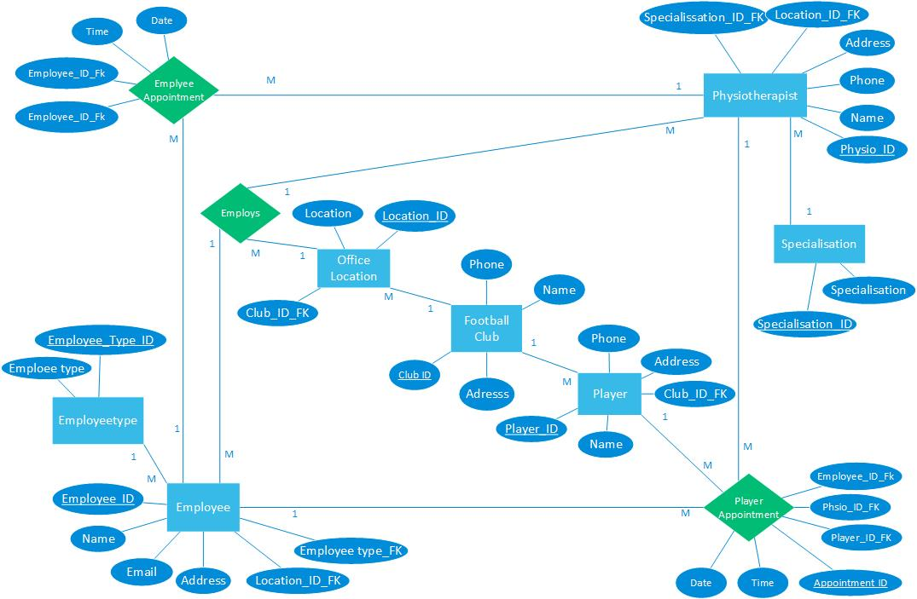

1. **Three tables with 5 records that satisfy the normalization forms (1NF, 2NF, and 3NF) are below.**
2. **Table One: Physiotherapists.**

|  |  |  |  |  |
| --- | --- | --- | --- | --- |
| Physiotherapists | | | | |
| Phsio_ID | Name | Phone | Address | Specialisation_ID_FK |
| 201 | Alan Mcdonald | 09343980 | 934 Great North Road, Grey Lyn | 601 |
| 202 | Lisa Selad | 02039456423 | 87 Symond Street, Eden Terrace | 602 |
| 203 | Andrew Dalad | 02465468490 | 120 Franklin Road, Freemans Bay | 603 |
| 204 | Christina Pele | 021456487489 | 4/89 Ocean Street, Mission Bay | 602 |
| 205 | Kayla Andge | 0973454377 | 4 King Avnue, Devonport | 601 |

1. **Table Two: Employees.**

|  |  |  |  |  |  |
| --- | --- | --- | --- | --- | --- |
| Employee | | | | | |
| ID | Name | Phone | Email | Address | Emplyee_Type_ID_FK |
| 101 | Eric Jolley | 098353454 | [eric.J@mtalbertfootball.co.nz](mailto:eric.J@mtalbertfootball.co.nz) | 18 Wesley Road, Wesley | 401 |
| 102 | Lily Hanas | 0234354609 | [lily.H@mtalbertfootball.co.nz](mailto:lily.H@mtalbertfootball.co.nz) | 5/30 Daroa Road, St Johns | 402 |
| 103 | Sofia Jersey | 0213900735 | [sofia.J@mtalbertfootball.co.nz](mailto:sofia.J@mtalbertfootball.co.nz) | 4B Wood Street, Freemans Bay | 403 |
| 104 | Lora Ara | 0205987739 | [lora.A@mtalbertfootball.co.nz](mailto:lora.A@mtalbertfootball.co.nz) | 1003 Alton Road, Northshore | 404 |
| 105 | John McCrane | 0248774546 | [john.C@mtalbertfootball.co.nz](mailto:john.C@mtalbertfootball.co.nz) | 3 Jervos Road, Herne Bay | 405 |

1. **Table Three: Players.**

|  |  |  |  |
| --- | --- | --- | --- |
| Player | | | |
| Player_ID | Name | Phone | Address |
| 30001 | David Todd | 021343987 | 23 Waterview Road, Freemans Bay |
| 30002 | Jason Ali | 020133096 | 1/189 Great South Road, Penrose |
| 30003 | Luke Glen | 09785343 | 90 Dominian Road, Mt Eden |
| 30004 | Jack Armstrong | 024243984 | B3, 109 Victoria Street, CBD |
| 30005 | William Lanord | 021098354 | 53 Beach Road, Takapuna |

**Part C – Database Implementation and Testing.**

1. Database implementation.
2. The database is created as below:

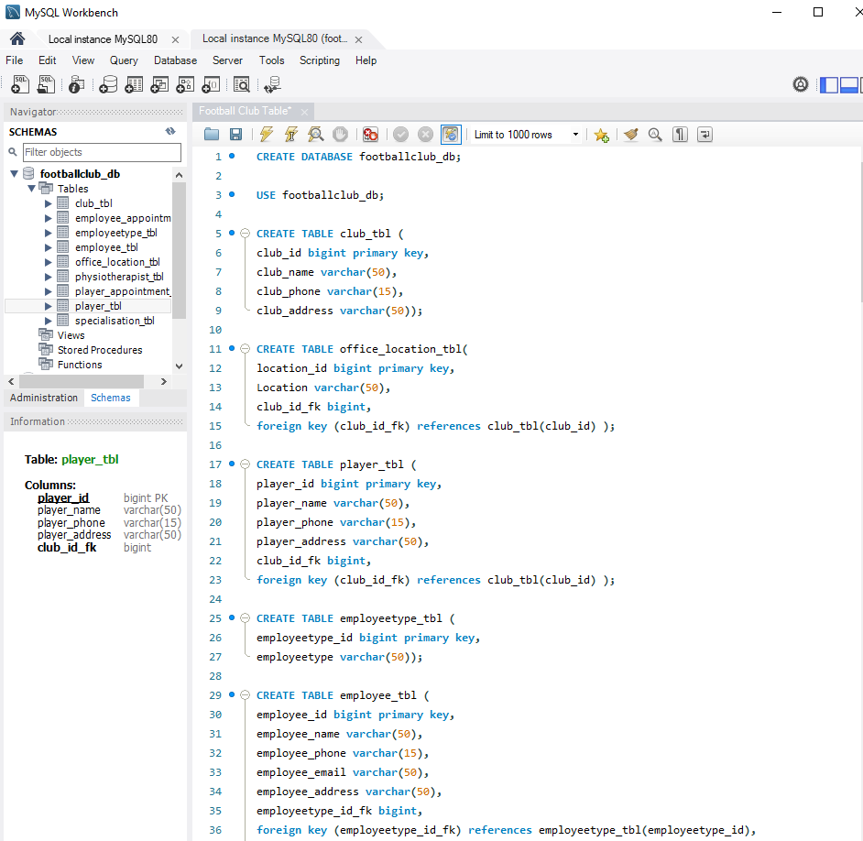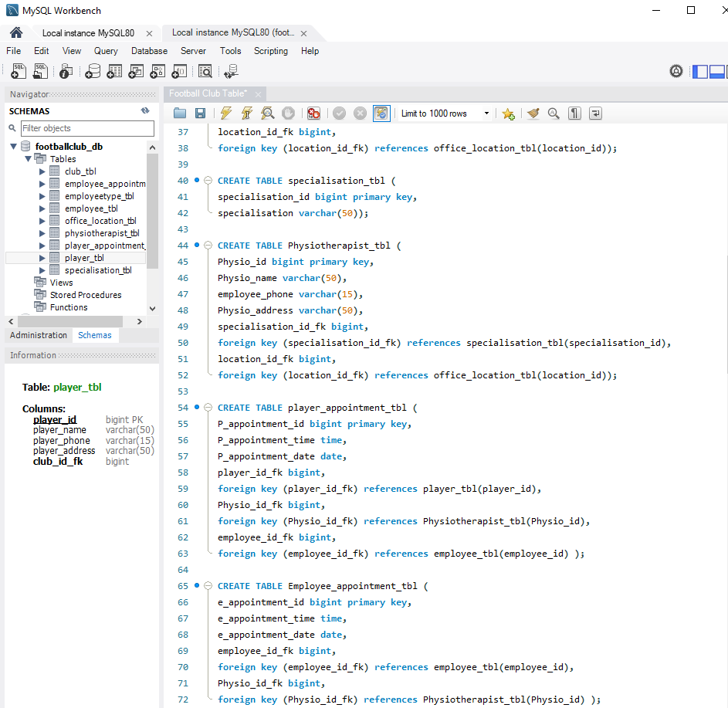

1. Populate each table and retrieve all records.

1). The Employee table was populated and retrieved as below:

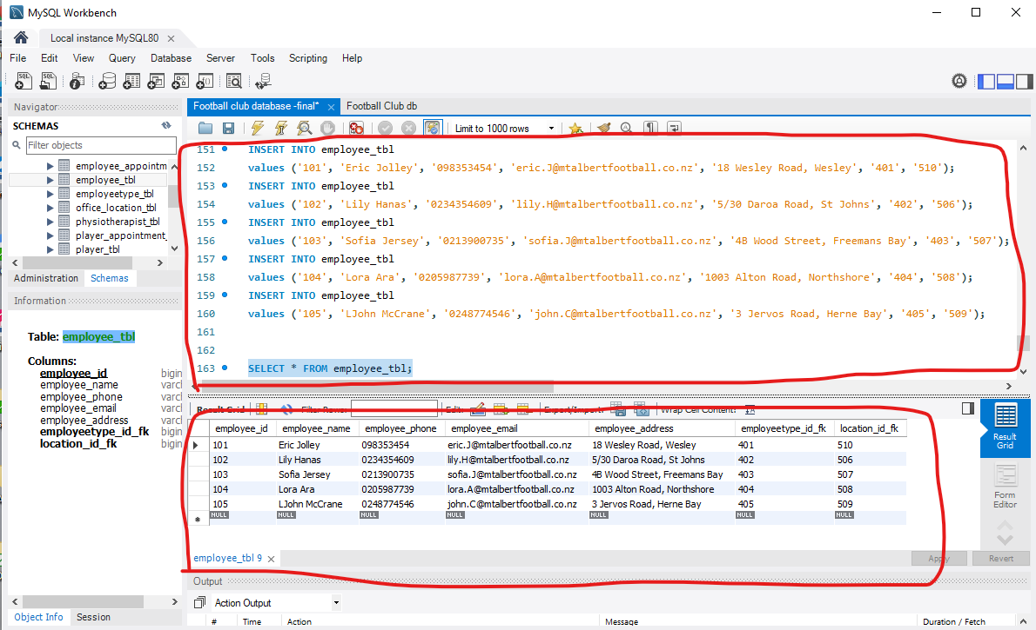

2). The Physiotherapists table was populated and retrieved as below:

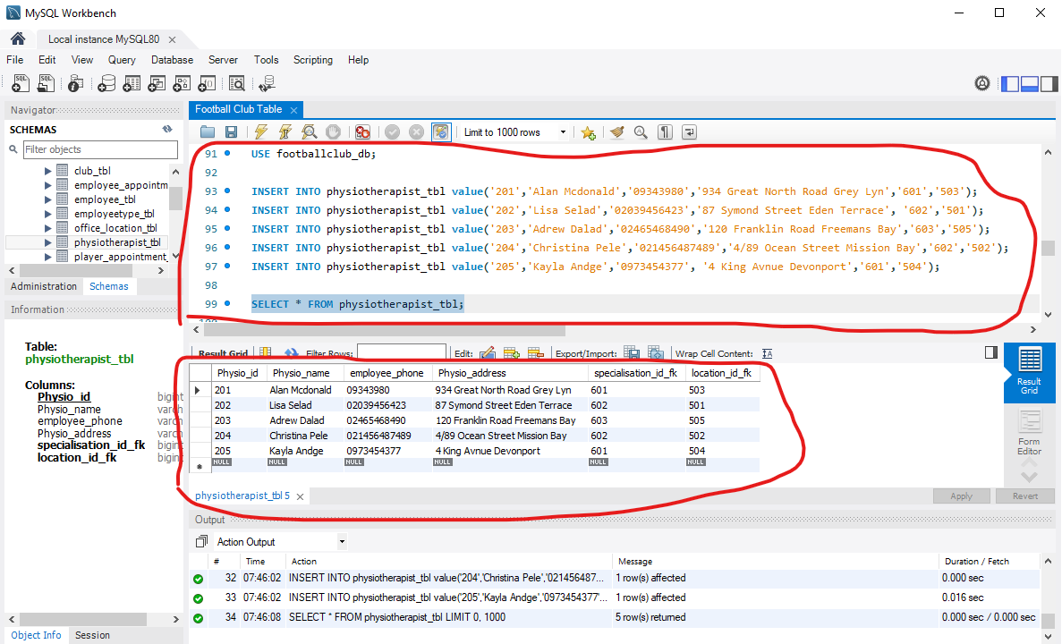

3). The Player table was populated and retrieved as below:

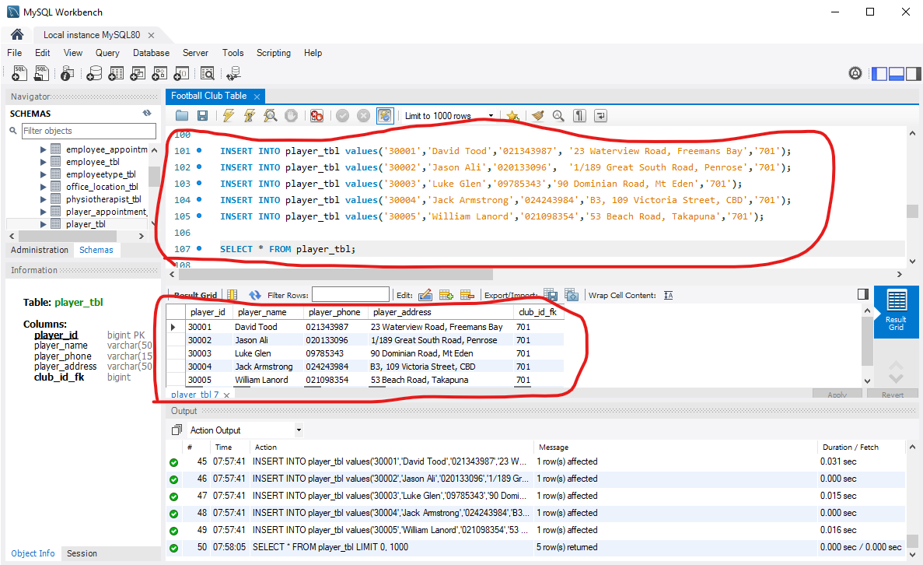

4). The Employee Type table was populated and retrieved as below:

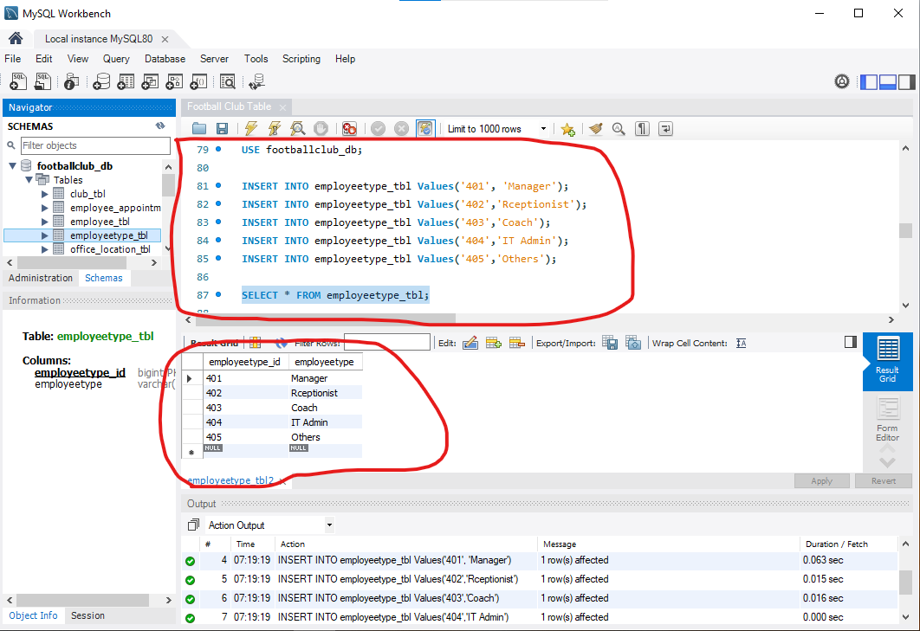

5). The Office Location table was populated and retrieved as below:

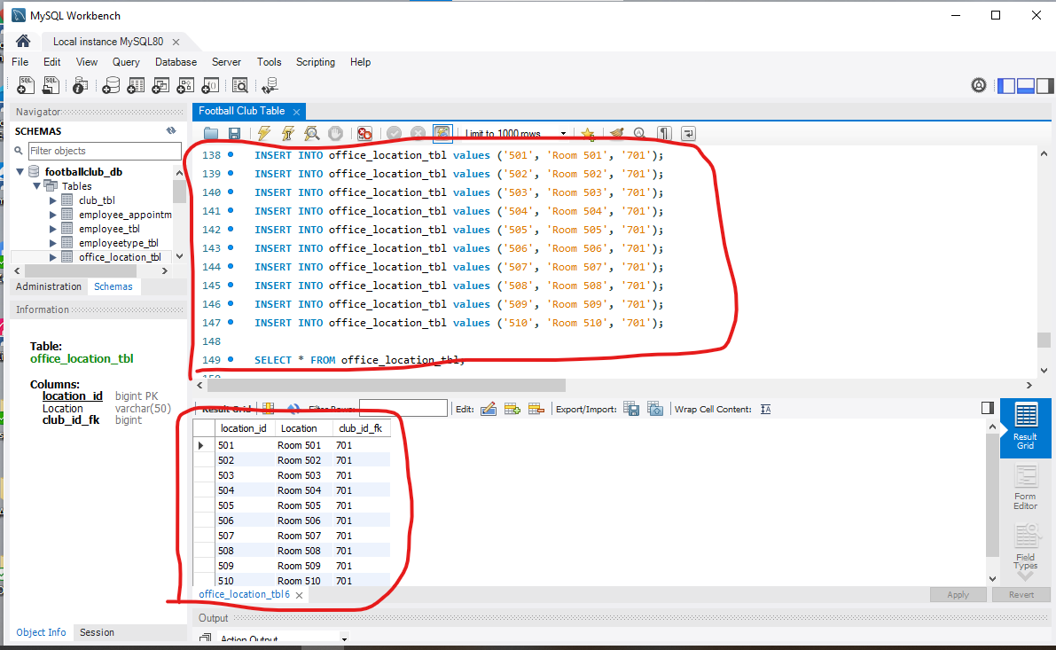

6). The Specialisation table was populated and retrieved as below:

7). The Club table was populated and retrieved as below:

8). The Player Appointment table was populated and retrieved as below:

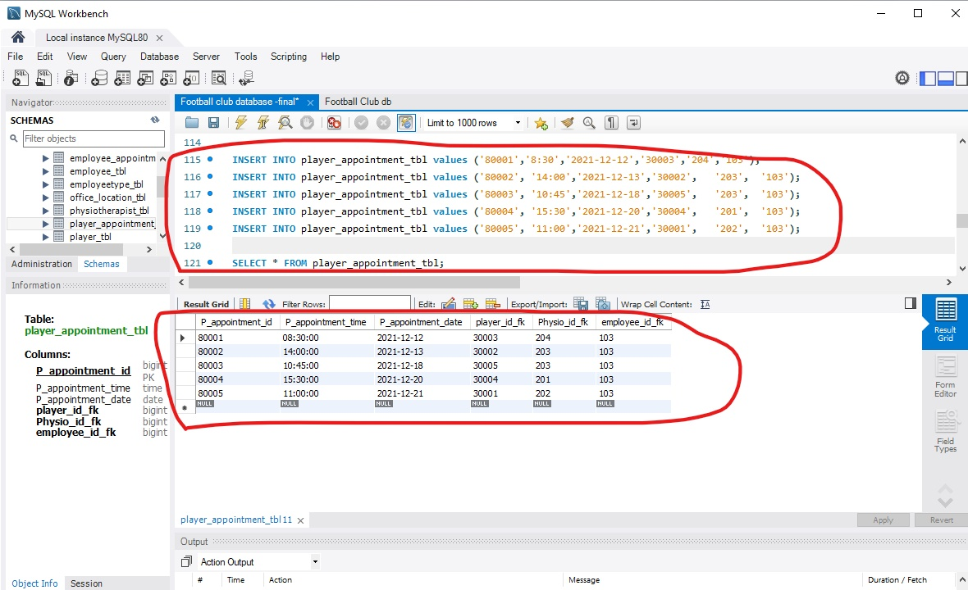

9). The Employee Appointment table was populated and retrieved as below:

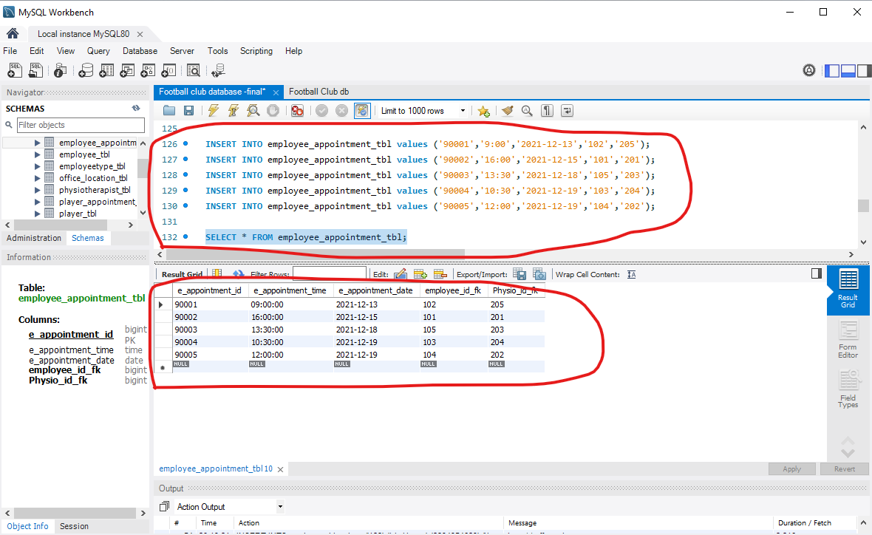

1. **Database testing.**
2. **Insert, update, and delete records of tables. TWO examples of each SQL command.**

**1). Two examples of insert command.**

**Example One**. The code of inserting values into the Player table and the results are highlighted as below:



**Example Two.** The code of inserting values into the Employee table and the results are highlighted as below:



**2). Two examples of the Update command.**

**Example One.** Update the existing Appointment Time “11:00” to “12:00” for Player Appointment ID “80005”.

The original table and record are highlighted as below:

The Update command codes, the updated table and its records are highlighted as below:

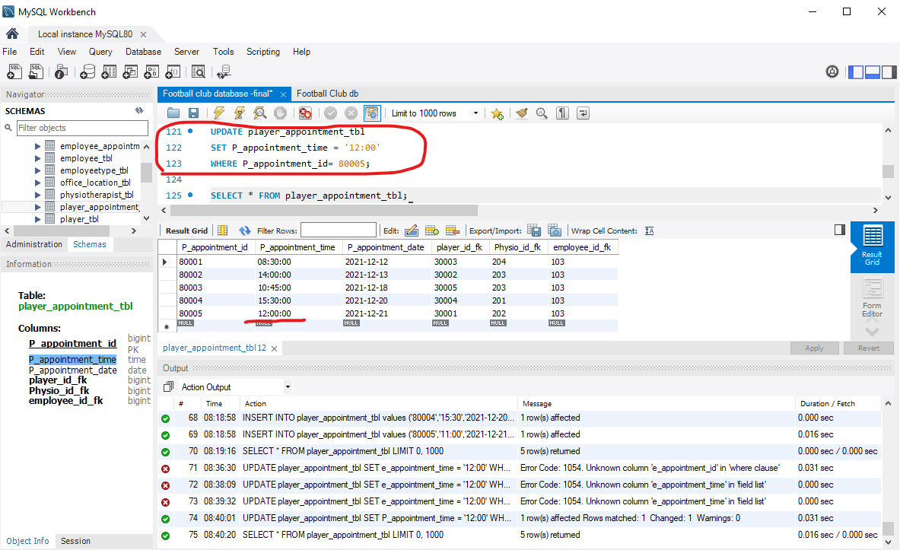

**Example Two**. Update the existing Address “53 Beach Road, Takapuna” to “23/109 Queen Street” for Player ID “30005”.

The original table and values are highlighted as below:

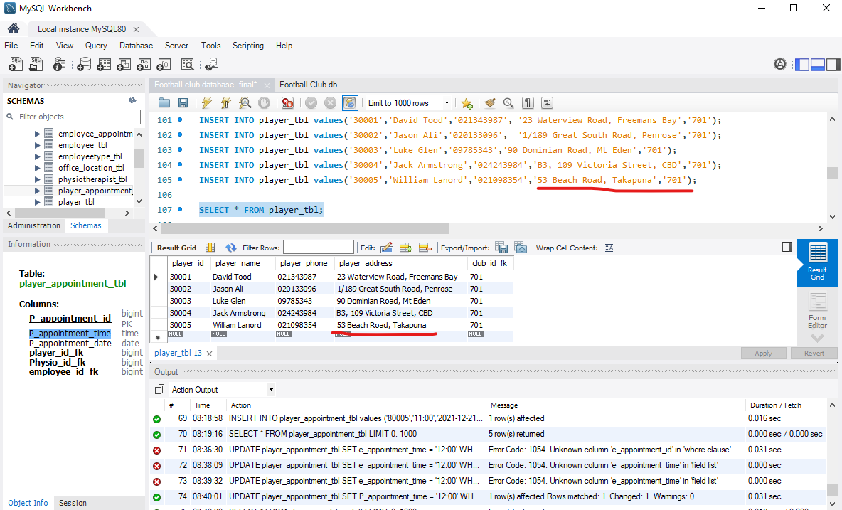

The Update command codes are circled, and the updated table and its records are highlighted as below:

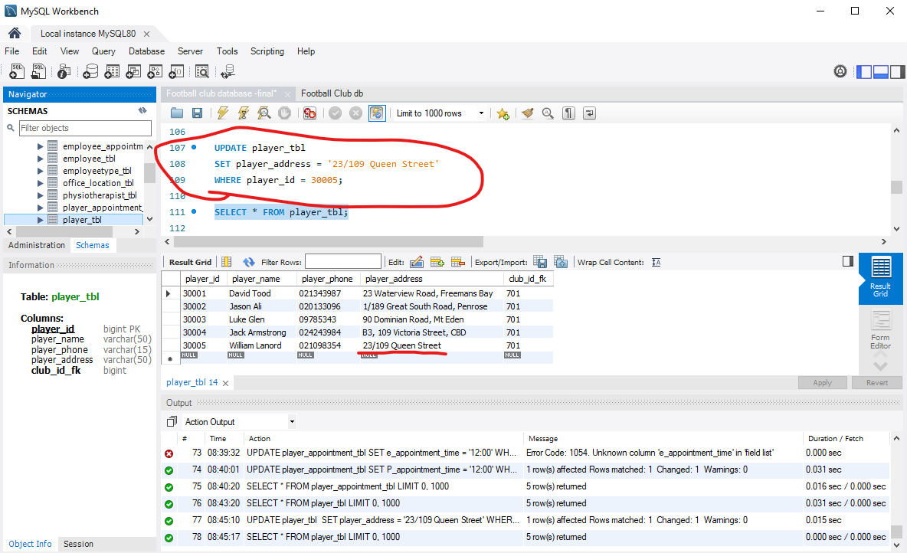

**3). Two examples of Delete command.**

**Example One**. Delete the existing Player Appointment ID “80005” and the rest of the records in the row.

The original table and records highlighted are below:

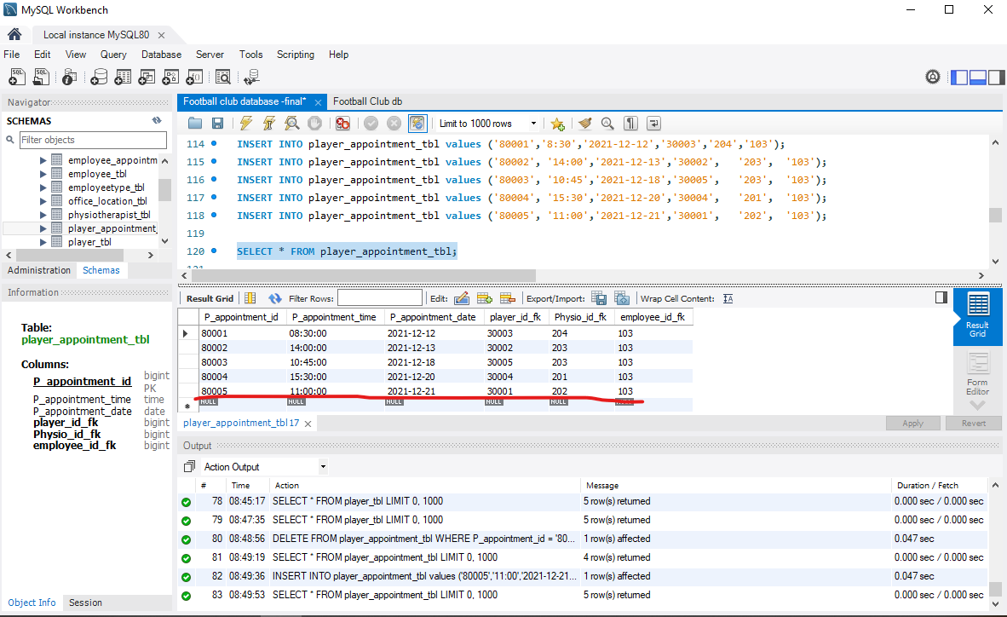

The code of the Delete command is highlighted below. We can see that the records of the Player Appointment ID “80005” are deleted from the table:

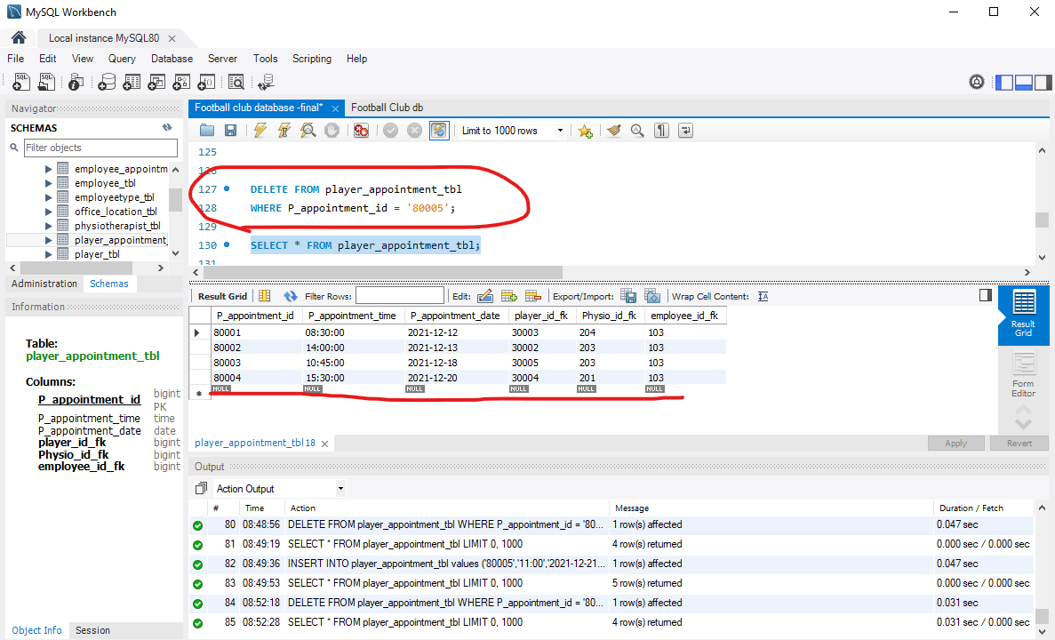

**Example Two**: Delete the existing Employee Appointment ID “90001” and the rest of the records in the row.

The original table and its records are highlighted as below:

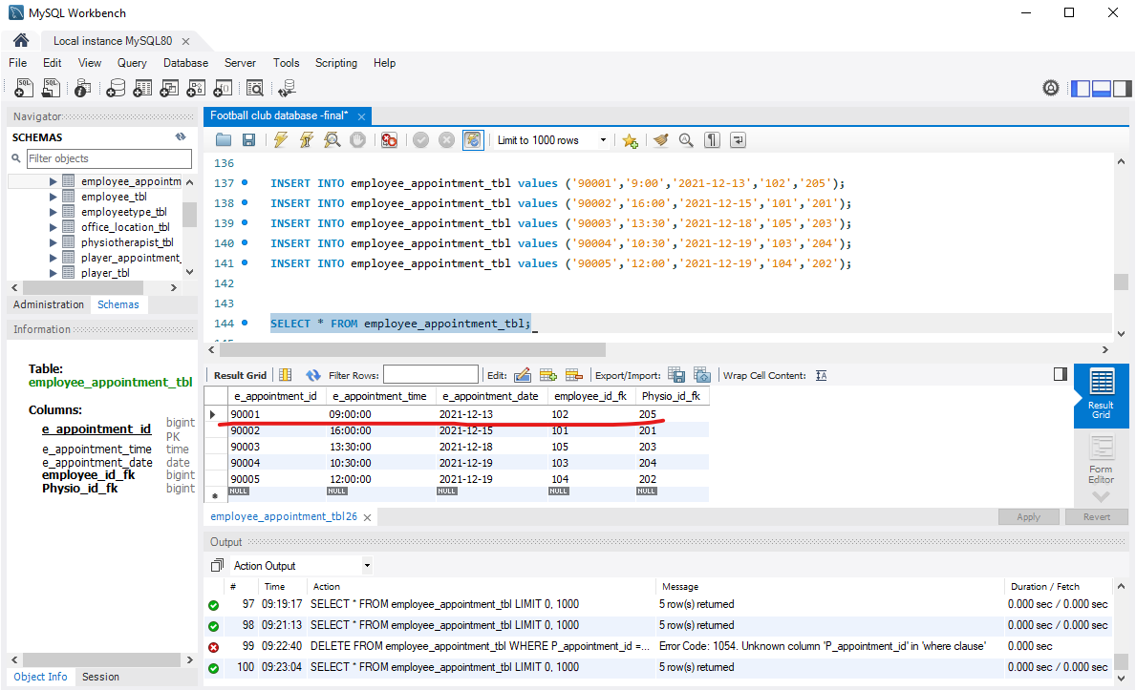

The Delete command code is circled as below. We can see the Employee Appointment ID “90001” and the rest of the records in the row are deleted from the table as circle below:

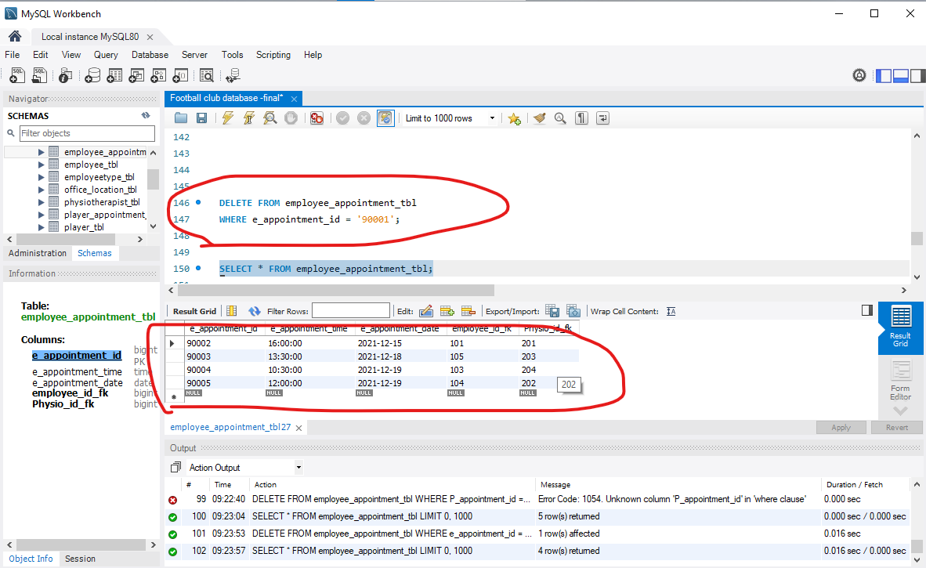

1. **Retrieve data from multiple tables.** TWO examples for data retrieval from 2 tables with either all columns or some columns.

**Example One**: Retrieval employees’ name and their appointments’ time and date from employee_tbl and employee_appointment_tbl as below:

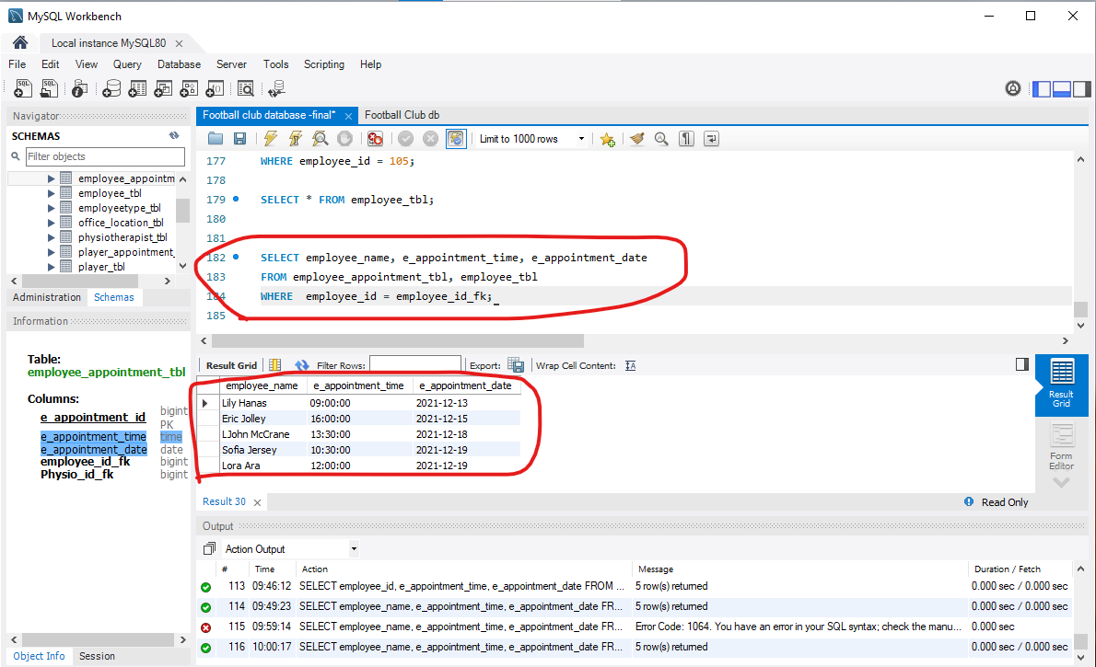

**Example Two**: Retrieval physiotherapists’ name and their specialisation from physiotherapist_tbl and specialisation_tbl as below:

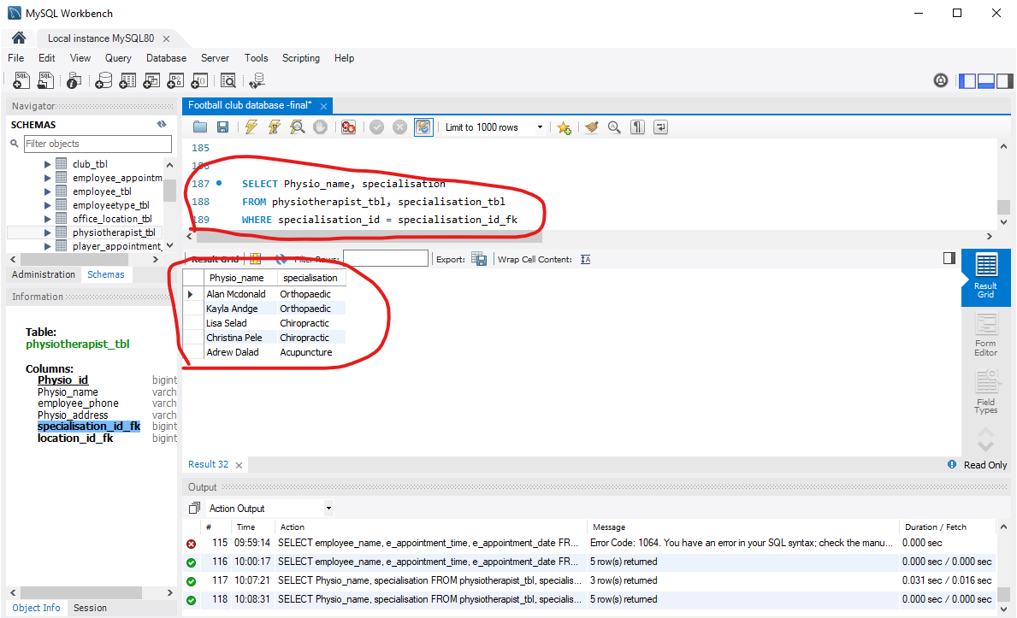

1. **Table integrity Testing.**

The SQL command used for table maintenance is “CHECK TABLE”.

1). The Screenshot of the CHECK TABLE command was used to check the “player_appointment_tbl” in the database and the result showed “OK” as blow:

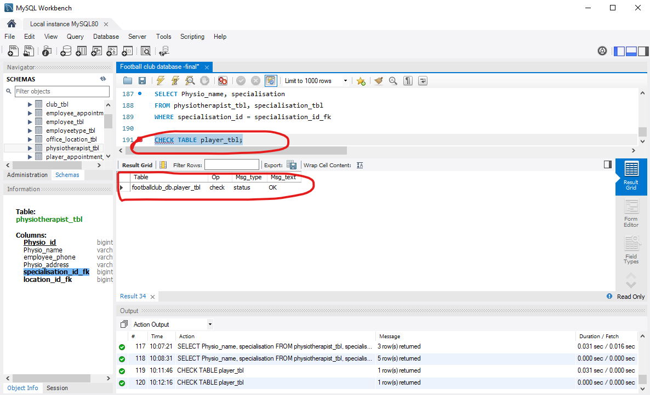

2). Explanation of SQL command ‘CHECK TABLE’: CHECK TABLE command checks the assigned tables in SQL for errors. It also checks views for problems, such as tables that are referenced in the view definition that no longer exist.

1. **Export the database and make a backup of the project database.**
2. **Export the database steps as below:**

**Step One**: Click on “Server” on MySQL, then “Data Export” circled as below:

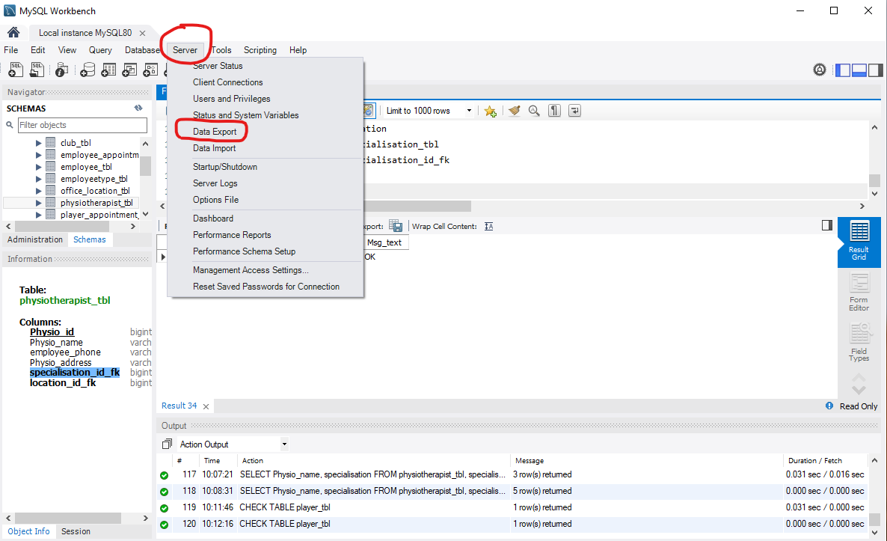

**Step Two**: After clicking on “Data Export”, a new page will appear as below. Tick all options which are circled in the screenshot below:

1. Tick the database “footballclub_db” that need to be exported.
2. Tick all tables of the database.
3. Tick the three options of “Objects to exports”.
4. Keep “Export to Self-Contained File”.
5. Tick “Include Create Schema”;
6. Click on “Start Export”.

**Step Three**: After clicking “Start Export”, a new page will appear and the export process will start. Once it’s done, there will be a message that shows “Export Complted” and the file location as circled below.

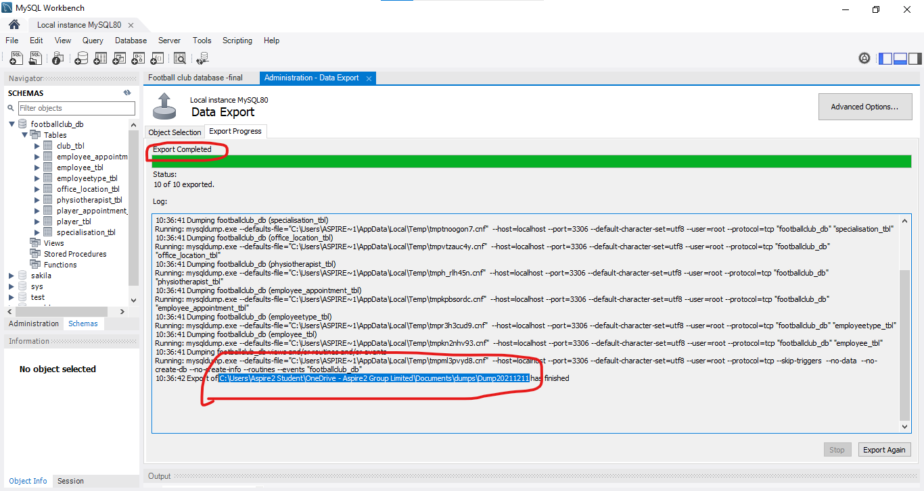

**Step Four**: The exported data is now shown in the destination file folder on the screenshot below:

**References:**

*What Are the Advantages of Database Management System?- Talent Economy. (2021, March 25). What Are the Advantages of Database Management System?- Talent Economy. ShineLearning.* [*https://learning.shine.com/talenteconomy/ta-technology/advantages-of-database-management-system/*](https://learning.shine.com/talenteconomy/ta-technology/advantages-of-database-management-system/)

*DAT536 Course Book.pdf: Database Development and Design. (2021). Instructure.com.* [*https://aspire2international.instructure.com/courses/1340/files/139545?module_item_id=73007*](https://aspire2international.instructure.com/courses/1340/files/139545?module_item_id=73007)

*Retest. (2012, April 4). Functional vs Non-Functional Requirements - Understand the Difference. ReQtest.* [*https://reqtest.com/requirements-blog/functional-vs-non-functional-requirements/*](https://reqtest.com/requirements-blog/functional-vs-non-functional-requirements/)

*Nordic Backup. (2018, February). Home Basic. Secure Cloud Backup Software | Nordic Backup.* [*https://nordic-backup.com/blog/7-steps-data-migration-plan/*](https://nordic-backup.com/blog/7-steps-data-migration-plan/)

*Branson, T. (2017, April 14). The 5 Best Reasons to Choose MySQL - and its 5 Biggest Challenges - Dataconomy. Dataconomy.* [*https://dataconomy.com/2017/04/5-reasons-challenges-mysql/*](https://dataconomy.com/2017/04/5-reasons-challenges-mysql/)

*Andrieiev, S. (2020, May 21). Functional vs Non-Functional Requirements: Differences And Examples. Medium; Medium.* [*https://jelvix.medium.com/functional-vs-non-functional-requirements-differences-and-examples-8cad343eec4e*](https://jelvix.medium.com/functional-vs-non-functional-requirements-differences-and-examples-8cad343eec4e)

*Cloud Storage and Data Backup Advantages | Record Nations. (2021). Record Nations.* [*https://www.recordnations.com/articles/cloud-storage-online-data-backup-advantages/*](https://www.recordnations.com/articles/cloud-storage-online-data-backup-advantages/)